DIRM Batch Direct Update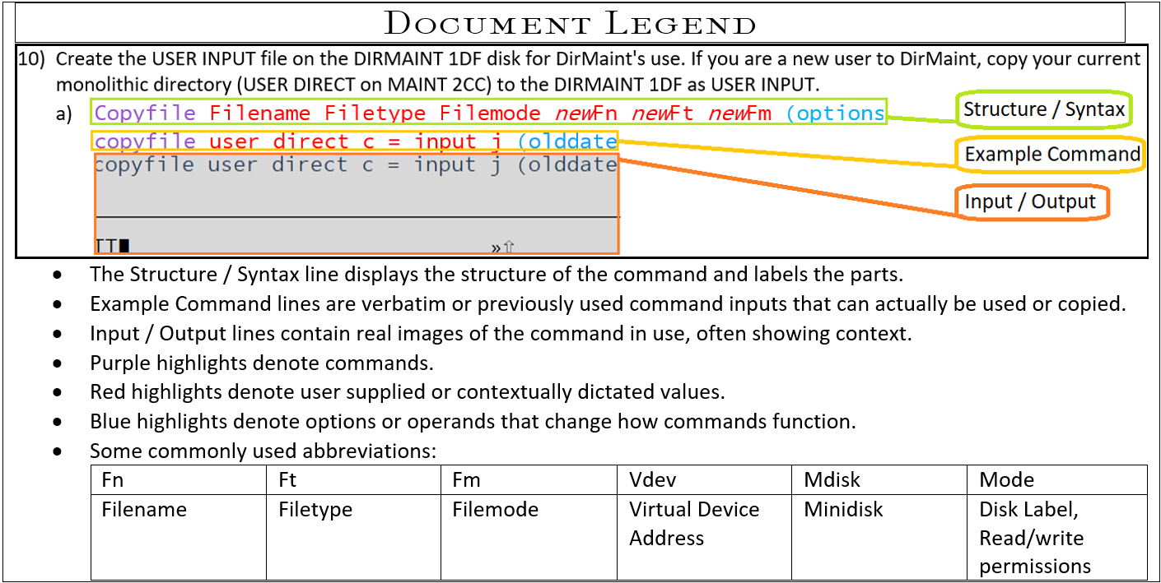

1. Place User Input on MAINT730’s 191 disk for easy access.
2. Log onto DIRMAINT.
3. Save the file as User Input to DIRMAINT’s 1DF MDISK (alternative file it there with DIRM file.)
   1. VMLINK USER MDISK  
      vmlink maint730 191  
      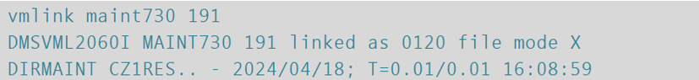
   2. Copyfile filename filetype filemode *new*filename *new*filetype *new*filemode (options  
      Copyfile user input x *user* *input* *e* (options  
      
   3. Rename User Direct to preserve it and prevent it from being used to build the directory.  
      Rename / *new*filename *new*filetype *new*filemode  
      Rename / *user* *oldirect* *e*  
      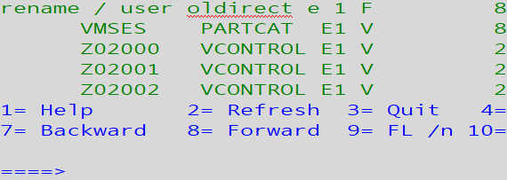
      1. Or alternatively:  
         Rename filename filetype filemode newFN newFT newFM  
         Rename user direct e user oldirect e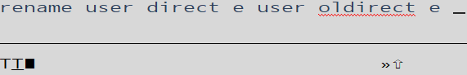
   4. Bring the changes online and place DIRMAINT back in service.  
      DVHBEGIN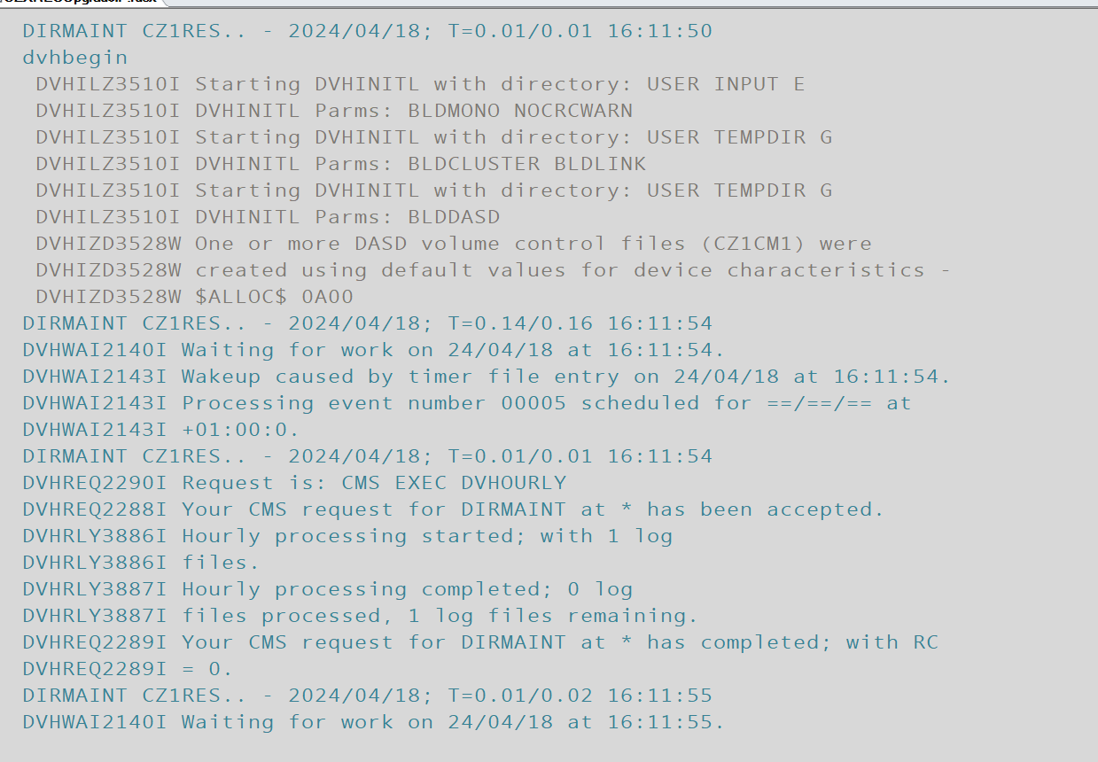
4. Disconnect from DIRMAINT and leave it running.  
   #cp command  
   #cp disconnect  
   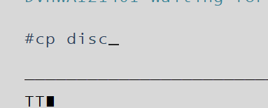
5. Test the changed by logging onto a user expected to have been added.